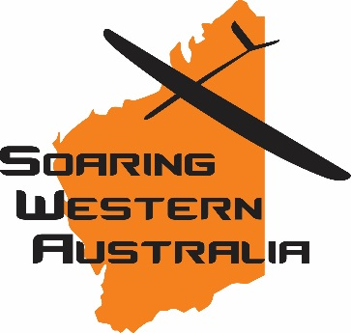
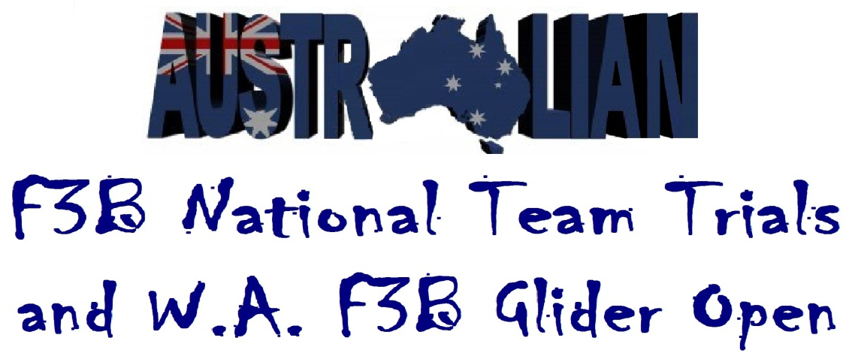
2022 WA F3B Open & 2023 World Champs. Australian F3B Team Trials
Saturday 10th September through to Sunday11th September 2022
Clackline FieldWe
Clackline WA
Entry Form
Name _______________________________________________________________

Postal Address _____________________________________________________________
Contact Details Mobile: ___________________email_______________________________
MAAA Number and club ____________________________
Entry Fees NIL
Entries Close Wednesday 31st August.
Please post or email entries to Tim Kullack C/O Perth Recruitment Services
PO Box 8003, FREMANTLE WA 6160
timk@perthrecruit.com.au
0438 995 200

